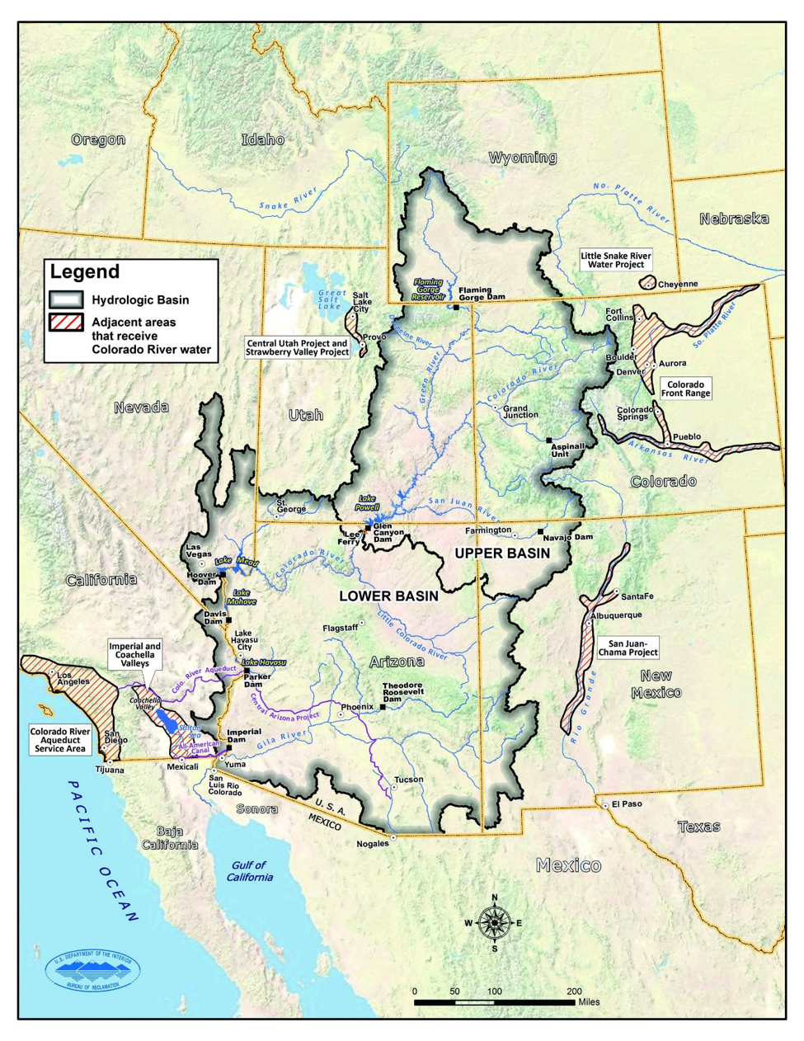

Prompt D: Analytical Solution to an Optimization Problem

Talha Quddoos- A02469393
Dr. David E. Rosenberg
CEE 6410- Civil Engineering Systems Analysis in the Age of Uncertainty
September 16, 2026

Analytical Solution to an Optimization Problem

Learning Objectives:
- Apply the Lagrangian method to analytically solve a demonstrative non-linear water resources optimization problem
- Present your work in a variety of formats required of practicing engineers, including written reports
The Problem
A water manager must allocate river water to an urban area and wetland as shown in Figure 1. If there are 320 ac-ft of water available in the river, how much water should the manager allocate to urban users and to the wetland to maximize total benefits?

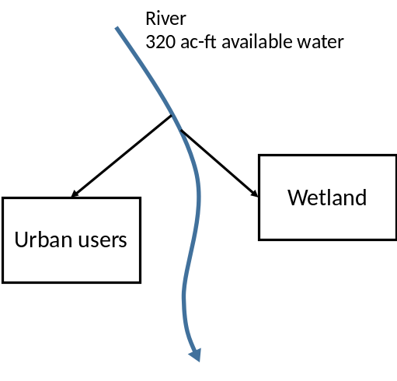
Figure 1. Schematic of water allocation decision problem

In your allocation decision, consider:
- Urban users are willing to pay $800 per acre-foot of supply (to avoid having to incur costs to truck in potable water),
- Wetland benefits derive from fees paid by hunters and fishermen for game and fish caught within the wetland. The number of game and fish produced in the wetland and available for catch is roughly proportional to the wetted surface area. Thus, assume the wetland benefits ($) from water allocated to the wetland (Q_{w}, ac-ft) can be described by the nonlinear function:

$$Wetland Benefits=2200 Q_{w}^{0.8}$$
Provide:
- A 1-sentence summary of the problem (5 pts)
- The Model Formulation in the format (15 pts)
  - Description of the dimensions of the problem.
  - Decision variables, Objective Function, and Constraints including definitions of parameters and variables and units of measurement.
- Analytical Solution using the Lagrangian Method (10 pts)
- Optimal Allocations and Total Benefits generated (5 pts).
- The additional benefits that would be generated if 10 more ac-ft of water were available in the river and who should be allocated the additional water (5 pts)

40 total points.

Summary
The given statement is a Lagrangian constraint optimization problem in which we (as a manager) are supposed to maximize the benefits (or revenue) of water by allocating it between urban users and wetlands.

Model Formulation
Dimensions
In the given problem, we have one dimension, which is the demand among which the water is going to be split. The demand dimension has the following elements.
- Urban Users
- Wetlands

Decision Variables
The decision variables for the dimension elements are as follows.
- Water allocation for urban users : Qu (acre feet)
- Water allocation for wetlands: Qw (acre feet)

For the allocated water, the benefits per demand element are as follows.
- Urban users water allocation benefits = $800 per acre foot
- Wetland water allocation benefits = $$2200 Q_{w}^{0.8}$ (given)

Objective Function
We have to maximize the water allocation benefits, so our objective function is benefit maximization. We can write it in the form of equation as follows.
$$f_{max}^{}=Urban user benefits+Wetland Benefits$$
$f_{max}^{}=800Q_{u}^{}+2200 Q_{w}^{0.8}$ ------ (1)
where $f_{max}^{}$ = objective function (maximizing the benefits) $

Constraints
In our problem, the availability of water supply in the river is a constraint, which is 320 acre-feet of water. We have to divide this water among two demand sites, i.e urban users and wetlands. The constraint equation can be written as follows.
$Q_{u}^{}+Q_{w}^{}=320$ or
$Q_{u}^{}+Q_{w}^{}-320=0$ ------ (2)

Analytical Solution
In order to solve this equation analytically we are proceeding with lagrangian method.
The lagrangian method can be written in the form of equation as.
$${L=Objective Function+λ(Constraint) }_{}^{}$$
Where,
$L$= Lagrangian,
$λ$ = Lagrangian Coefficient

Using values from eq 1 and 2 we get the following lagrangian equation.

$L= 800Q_{u}^{}+2200 Q_{w}^{0.8}+λ(Q_{u}^{}+Q_{w}^{}-320)$ ------ (3)

Upon taking derivatives of eq 3 with respect to $Q_{u}^{}$, $Q_{w}^{}$and $λ$ and solving for unknowns we get values for $Q_{u}^{}$and $Q_{w}^{}$ .
$L= 800Q_{u}^{}+2200 Q_{w}^{0.8}+λ\left(Q_{u}^{}+Q_{w}^{}-320\right)$

$\frac{dL}{dQ_{u}^{}}= 800+λ$ = 0 ------ (4)
$λ$ = -$800$
$\frac{dL}{dQ_{w}^{}}=\left(0.8*2200\right)Q_{w}^{0.8-1}+λ=0$ ------ (5)

$$\left(0.8*2200\right)Q_{w}^{0.8-1}+λ=0$$
$$\left(0.8*2200\right)Q_{w}^{0.8-1}+λ=0$$
1760$Q_{w}^{-0.2}+λ=0$
$$\frac{1760}{Q_{w}^{0.2}}+λ=0$$
$$1760=-λQ_{w}^{0.2}$$
$$1760=-(-800)Q_{w}^{0.2}$$
$$2.2=Q_{w}^{0.2}$$
$$Q_{w}^{}=51.53 acre feet$$
$\frac{dL}{dλ}=\left(Q_{u}^{}+Q_{w}^{}-320\right)$ = 0 ------ (6)
$$Q_{u}^{}+Q_{w}^{}=320$$
$$Q_{u}^{}=320-Q_{w}^{}$$
$Q_{u}^{}=320-51.53$ = 268.47 acre feet

Optimal Allocations and Total Benefits
The values calculated from lagrange equation give us the optimum acre feet for urban users and wetlands. Plugging in the values give us the total benefits against that optimum water allocation.
Benefits from urban users = $800Q_{u}^{}=$ 800 x 268.47 = $214,776
Benefits from wetlands = $$2200 Q_{w}^{0.8}=2200({51.53}_{}^{0.8})$ = $51,531.26
Total Benefits = $214,776 + $51,531.26 = $266,307

Additional Benefits
According to the problem statement we have to compute the additional benefits if we add 10 acre feet of water and also who should be allocated this water to satisfy our objective of maximizing the benefits. For this, we are computing the total benefits for two cases. Case 1 when all of the additional water is diverted to Urban Users and Case 2 when all of the additional water is diverted to the
Case 1: Benefit if the additional water is allocated to urban users
800 x (total urban user water)
= 800x278.47 = $222,776
Total benefit = 222,776 + 51,531.26 = $274,307.26 which is $8,000 more than the optimum condition.
Case 2:
Additional benefit if the additional water is allocated to wetlands
= $2200* {total wetland water}_{}^{0.8}$
= $2200* {(61.53)}_{}^{0.8}$
= $59,387.11
Total benefit = $214,776 + $59,387.11 = $274,163.11 which is $7,856.11 more than the optimum condition.
Since case 1 gives more total benefit, the additional 10 acre feet of water should be diverted to satisfy urban user demand.

Conclusion
In the problem above we successfully modelled a constraint optimization problem using Lagrangian analytical method. The maximum benefit for water $266,307 is obtained when 268.47 acre feet of water is allocated to urban users and $51.53 acre feet$of water is allocated to wetlands. To maximize profits, any additional amount of water should be directed to urban users as directing it to urban users is more rewarding.

Use of Artificial Intelligence (AI)
I used Claude AI to refresh my concepts before proceeding with the assignment.
The transcript for the interaction can be accessed using the following link. https://claude.ai/share/f622301b-4379-43a0-bd0e-5a7985ddd748

Category  (Max. Score) | No Evidence | Doesn’t Meet Standard | Nearly Meets Standard | Meets Standard | Exceeds Standard | Self- Score | Instructor Score
Title  (1) | Absent  0 | Evidence of two or less  0 | Evidence of three  0 | Evidence of four  1 | Title – can assess main point from title alone; Name, Instructors’ Names, Course, Date, Neatly finished 1 | 1
Introduction  (3) | Absent, no evidence  0 | There is no clear introduction or main topic.  1 | Introduction states the main topic but either:  - Does not give a full overview, Or:  - Too detailed, leading to annoying repetition later. 2 | The introduction states the main topic and previews the structure of the report.  2 | The introduction states the main topic and previews the structure of the report. Good overview of the problem and solution approach. Gives enough detail to motivate the reader to continue reading.  3 | 3
Organization and structural development of the idea  (10) | No content provided.  0 | Paragraphs fail to develop the main idea. No section headers or guide to help the reader understand how material is organized. 1 – 5 | Organization of ideas not fully developed. Paragraphs lack supporting detail sentences. No transitions and/or ineffective section headers.  6 - 7 | Paragraph development present but not perfected. Each paragraph has sufficient supporting detail sentences. Few transitions. 8 | Writer demonstrates logic and sequencing of intro, procedure, results, and conclusions through well-developed section headers, paragraphs, and transitions. The first sentence of each paragraph is the summary sentence. 9 - 10 | 10
Technical Correctness  (70) | Questions not addressed.  3 – 42% | The writer has no clue what they are talking about.  45 – 58% | Sketchy: left out required design points. Did not work on this as much as you should have, and it shows. Many important answers are incorrect.  61 – 79% | Discussion lacks adequate detail, but all the necessary points are covered and nearly all answers are correct.  82 – 88% | Provides what was explicitly asked for. The function of each piece is demonstrated to the reader in adequate, but not overwhelming, detail. Answers are correct and reasonable.  91 – 100% | 70
Category  (Max. Score) | No Evidence | Doesn’t Meet Standard | Nearly Meets Standard | Meets Standard | Exceeds Standard | Self- Score | Instructor Score
Word Usage and Format  (10) | Not applicable | Numerous and distracting errors in punctuation, capitalization, spelling, sentence structure, word usage, significant figures, tables, and figures. Data vomited onto page(s). Unacceptable / unprofessional at the graduate level. 1 – 5 | Misspelled words, poor English grammar and word choice. Main body of report is either longer or significantly less than one page. Figures are too small and/or under-labeled, although they are usually of acceptable quality and focus. Tables incoherent or not cohesive. Bad font sizes. Too much or too little data in appendices. Could be improved by being more meticulous.  6 - 7 | Almost no errors in punctuation, capitalization, spelling, sentence structure, word usage, significant figures, and presentation of figures, tables, and appendices. Main body of report is one page or less  8 | Punctuation, capitalization, spelling, sentence structure, word usage, and significant figures all correct. Main body of report is one page or less. Clear, consistent fonts. Good word processing skills. Figures have adequate contrast. Informative figure and table titles and legends. Figures have appropriate axis tick spacing, labels, units, and legends. Table columns cohesive, labeled, and specify units. Document is stapled. Appendices, if provided, are separated by topic, and each have a title, discussion, and proper formatting and display of information 9 - 10 | 10
Conclusion  (4) | Absent  0 | Incomplete and/or not focused. 1 | The conclusion does not adequately restate the main results. 2 | The conclusion restates the main results. 3 | The conclusion restates the main results, and is an effective summary. 4 | 4
References  (0) | Absent  0 | Numerous errors, off-the-wall sources used. 0 | Some errors in citing format; more sources should be cited.  1 | Prior work cited with few errors.  2 | All prior work and data sources are cited in the correct format with no errors.  2 | NA | NA
TOTAL (98) |  |  |  |  |  | 98

Instructor Feedback:

_________________________________________________________________________________________________________________________________________________

